Debugmap ReadMe

Dispenser Caroussel (dispenserkarussellv1debug)
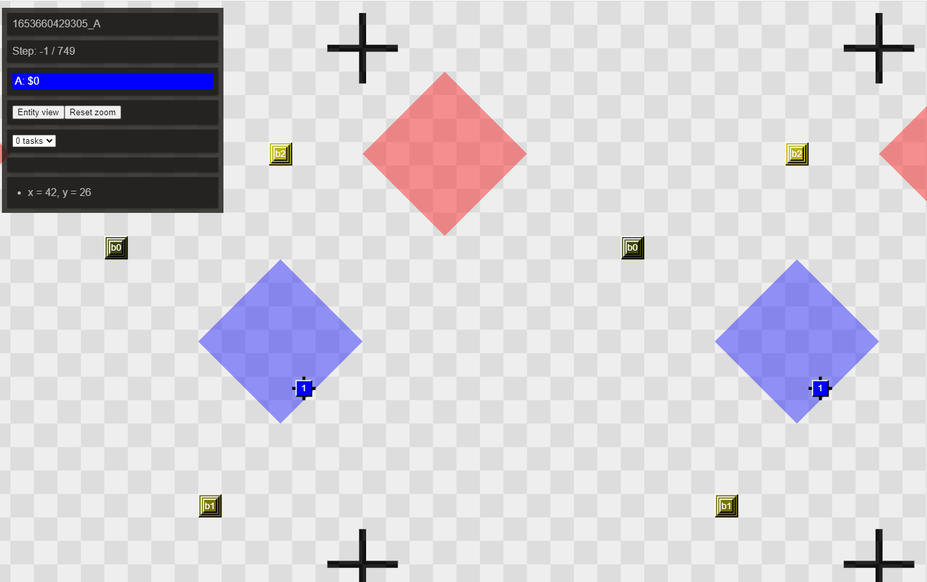
This map trains one agent in his programm loop task-dispenser-block-goalzone-submit.

Messagemania (messagemaniav1debug)

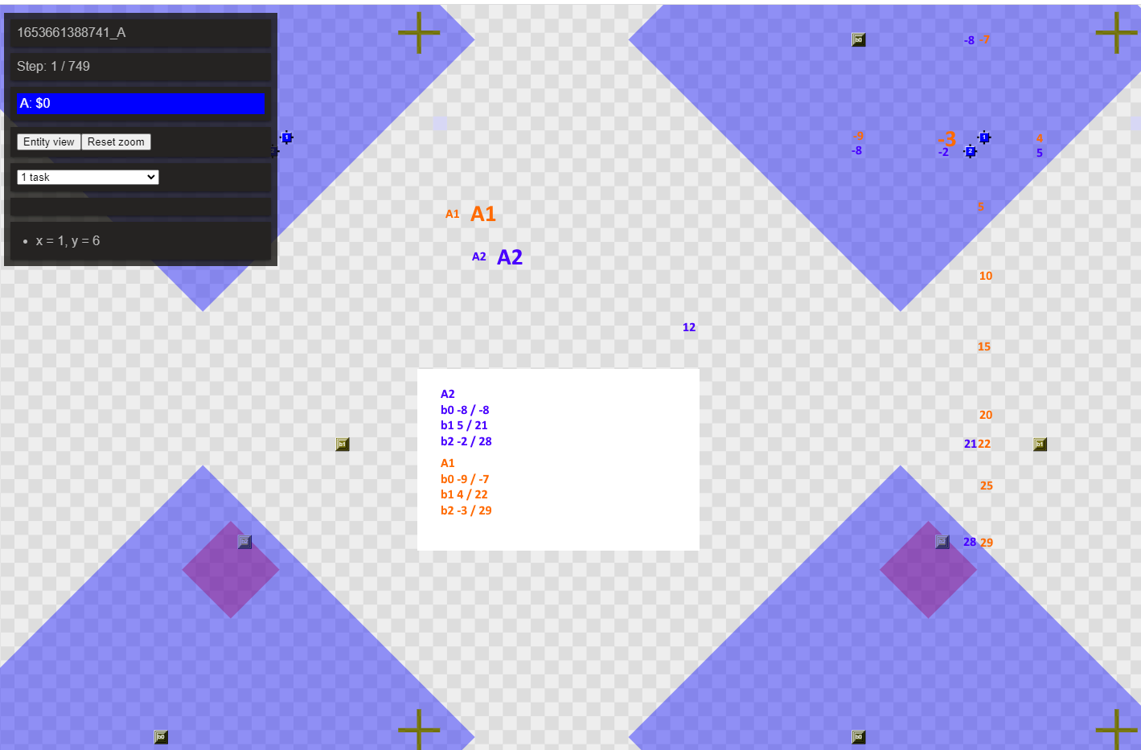

This map controls agent coordinates by having human calculated map coordinates to check against agents found coordinates in program logic. Especially useful for offset calculations with 2 agents or more.

Oneisnotenough (oneIsNotEnoughv1debug)

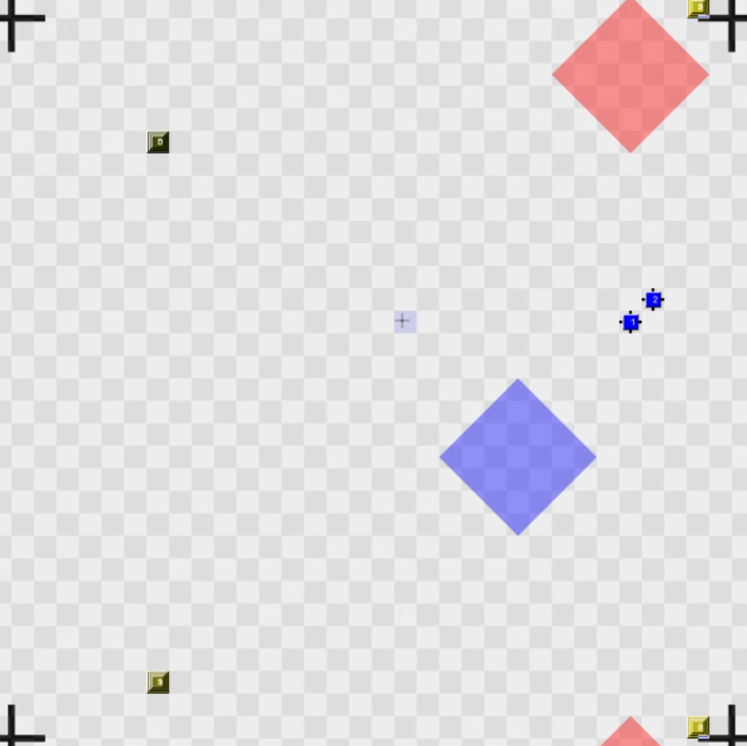

This map is like dispenserkarussellv1debug but for 2 block tasks.

Worldsize check (theWorldIsNotEnoughv1debug)
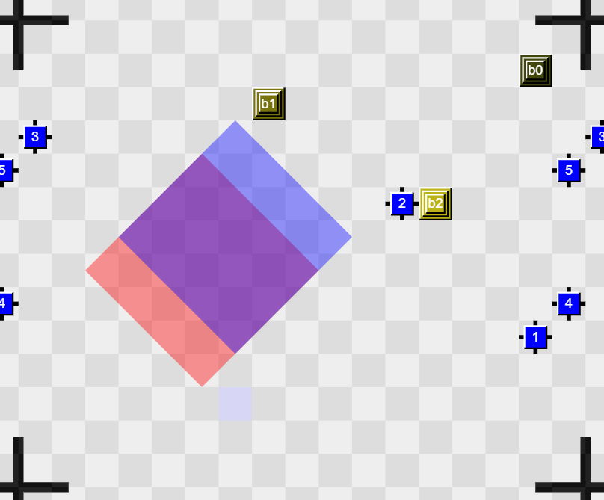
This map is smaller to enable the agents to find the worldsize faster than in bigger maps.

3 block task training (twothreetasktrainer)
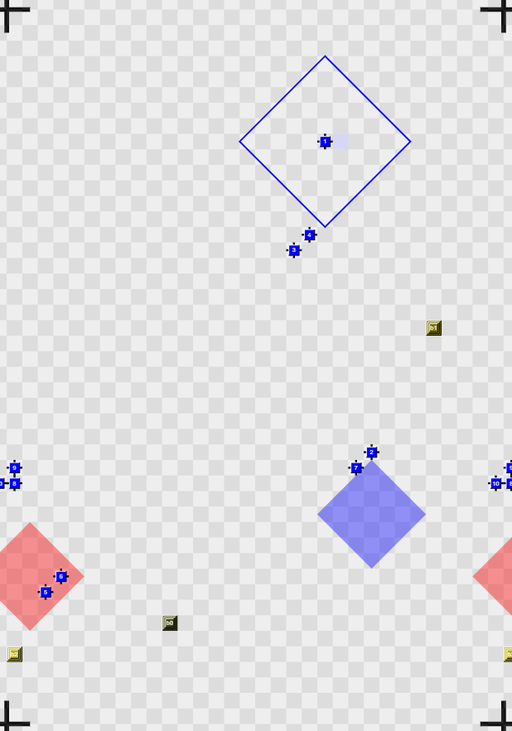
A map with only 3 block tasks active to train a big team on 3-tasks and message coordination between them. Another version akin to dispenser coroussel.

